To: Mike Carroll Date: 22 May 200e

From: Tom De Vries

Subject: KCAT Validation Case

See if I have decoded your problem specification correctly:

System Equations:

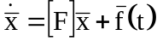

State Vector:

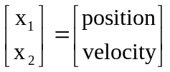

System Description Matrix:

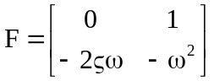

Forcing Function:

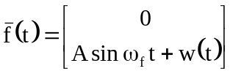 only model Cov(w) = Q

Calculations:
Initializations:
Transition Matix:

Covariance Matrix:

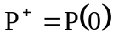

Extrapolation:

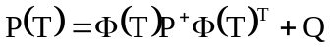
Gains:

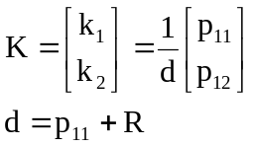

Covariance Reset:



